**PIZZA SALES SQL QUERIES**

**A.KPI’S**

**1.Total Revenue**

SELECT SUM(total_price) AS Total_Revenue FROM pizza_sales

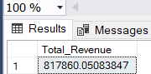

**2. Average Order Value**

SELECT SUM(total_price)/COUNT(DISTINCT order_id) AS Average_Order_Value

FROM pizza_sales

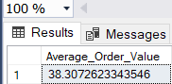

**3. Total Pizza Sold**

SELECT SUM(quantity) AS Total_Pizza_Sold FROM pizza_sales

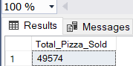

**4. Total Orders**

SELECT COUNT(DISTINCT order_id) AS Total_Orders FROM pizza_sales

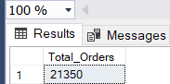

**5. Average Pizza Per Orders**

SELECT CAST(CAST(SUM(quantity) AS DECIMAL(10, 2))/CAST(COUNT(DISTINCT order_id) AS DECIMAL(10, 2)) AS DECIMAL(10, 2)) AS Avg_Pizzas_Per_Orders FROM pizza_sales

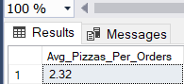

**B. CHARTS REQUIREMENT**

**1. Hourly Trend For Total Orders**

SELECT DATEPART(HOUR, order_time) AS Hours_, COUNT(DISTINCT order_id) AS Total_orders FROM pizza_sales GROUP BY DATEPART(HOUR, order_time) ORDER BY Total_orders DESC

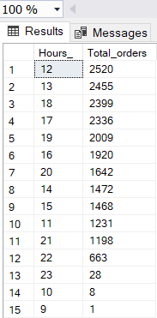

**2. Daily Trend For Total Orders**

SELECT DATENAME(DW, order_date) AS Order_Day, COUNT(DISTINCT order_id) AS Total_Orders FROM pizza_sales GROUP BY DATENAME(DW, order_date)

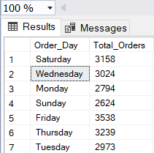

**3. Monthly Trend For Total Orders**

SELECT DATENAME(MONTH, order_date) AS Month_Name, COUNT(DISTINCT order_id) AS Total_Orders FROM pizza_sales GROUP BY DATENAME(MONTH, order_date)

ORDER BY Total_Orders DESC

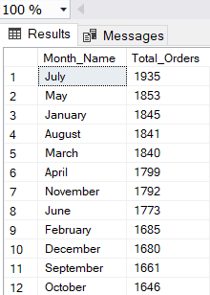

**4. Percentage of sales by Pizza Category**

SELECT pizza_category, CAST(SUM(total_price) * 100 / (SELECT SUM(total_price) FROM pizza_sales) AS DECIMAL(10, 2)) AS Percentage_of_Sales FROM pizza_sales

GROUP BY pizza_category ORDER BY Percentage_of_Sales DESC

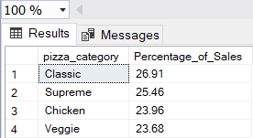

**5. Percentage of sales by Pizza size**

SELECT pizza_size, CAST(SUM(total_price) * 100 / (SELECT SUM(total_price) FROM pizza_sales) AS DECIMAL(10, 2)) AS Percentage_of_Sales FROM pizza_sales

GROUP BY pizza_size ORDER BY Percentage_of_Sales DESC

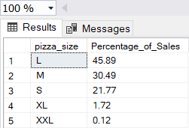

**6. Total Pizzas sold by Pizza Category**

SELECT pizza_category, SUM(quantity) AS Number_of_pizza_sold FROM pizza_sales

GROUP BY pizza_category ORDER BY Number_of_pizza_sold DESC

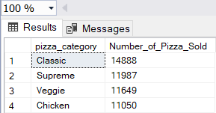

**7. Top 5 Best and Worst sellers Pizza by Total Revenue, Total Quantity and Total Orders**

**A. Top 5 Best by Total Revenue**

SELECT TOP 5 pizza_name, SUM(total_price) AS Total_Revenue FROM pizza_sales GROUP BY pizza_name ORDER BY Total_Revenue DESC

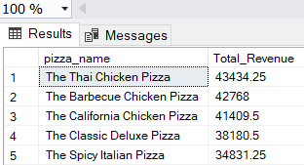

**B. Top 5 Worst by Total Revenue**

SELECT TOP 5 pizza_name, SUM(total_price) AS Total_Revenue FROM pizza_sales

GROUP BY pizza_name ORDER BY Total_Revenue ASC

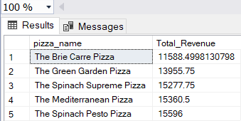

**C. Top 5 Best by Total Quantity**

SELECT TOP 5 pizza_name, SUM(quantity) AS Total_quantity FROM pizza_sales

GROUP BY pizza_name ORDER BY Total_quantity DESC

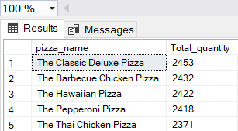

**D. Top 5 Worst by Total Quantity**

SELECT TOP 5 pizza_name, SUM(quantity) AS Total_quantity FROM pizza_sales

GROUP BY pizza_name ORDER BY Total_quantity ASC

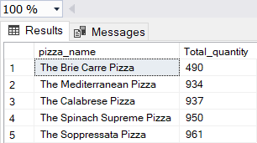

**E. Top 5 Best by Total Orders**

SELECT TOP 5 pizza_name, COUNT(DISTINCT order_id) AS Total_Orders FROM pizza_sales

GROUP BY pizza_name ORDER BY Total_Orders DESC

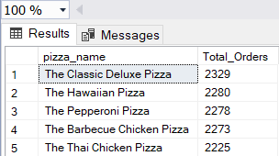

**F. Top 5 Worst by Total Orders**

SELECT TOP 5 pizza_name, COUNT(DISTINCT order_id) AS Total_Orders FROM pizza_sales

GROUP BY pizza_name ORDER BY Total_Orders ASC

